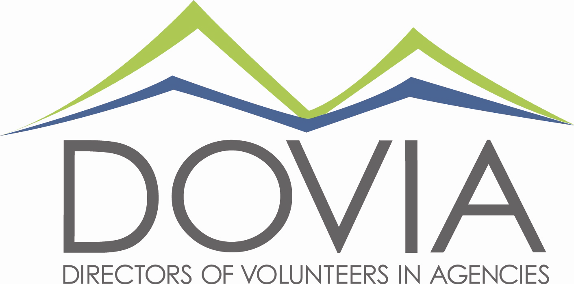

The Mission of DOVIA Colorado is to promote professionalism in the field of volunteer management, advocate for issues concerning volunteerism, and provide networking and educational opportunities for volunteer managers.
Annual Report for 2017
Membership:
- In 2014, DOVIA Colorado had 44 members
- Now, 210 paying members with an additional 252 members under those organizations = 462 volunteer professionals receiving education and support!
Becoming a better statewide organization:
- We have education/networking sessions in Larimer, Boulder/ Broomfield, Denver, and now Colorado Springs
- We have amazing committee members from the above regions
- We want more regions represented!
Growing brand and reputation:
- The L.A. DOVIA referred the Chair of the Nevada DOVIA to us because we are "The Gold Standard!"
- UServUtah wants to use DOVIA Colorado as the model for starting a DOVIA in Utah
Moving forward:
- In August, the Board of Directors did some strategic planning and decided to become "The Diamond Standard!” We cannot do this without YOU!

